**May 2014 SL P1**

**Section A**

1. Identify **two** features that need to be considered when planning a new computing system for

an organization. [2]

1. Explain what is meant by beta testing. [2]
2. Describe **one** advantage and **one** disadvantage of using observations to gather information

when planning a new system. [4]

1. Outline **one** usability issue associated with the design of mobile devices. [2]
2. Distinguish between the use of **two** types of primary memory. [2]
3. Outline, with an example, one benefit of using computer-aided design (CAD) applications. [2]
4. Outline how a colour can be represented in a computer. [2]
5. Identify **two** key features of a peer-to-peer (P2P) network. [2]
6. Define the term data packet. [2]
7. Explain why the speed of data transmission across a network can vary. [3]
8. Explain why an object is an example of abstraction. [2]

**Section B**

1. Harry is Tired (T) depending on the following three variables:

• Work (W)

• Hunger (H)

• Sun (S).

Harry is tired if:

• he works and he is hungry

• he works and it is not sunny

1. Represent, as a single logical expression, the conditions that cause Harry to be tired. [3]
2. Construct the truth table to show when Harry is tired. [4]

A professor notices that students are generally very tired and decides to investigate the

relationship of tiredness with Work, Hunger and Sun.

Consider the following truth table which shows the conditions for Tired based on Work,

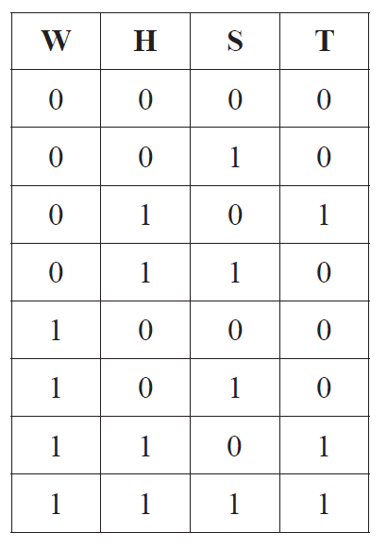Hunger and Sun.

The conditions for one of the students to be tired can be expressed in the following array,  
 TIRED, where the index is equivalent to the combination of W, H and S in the truth table.

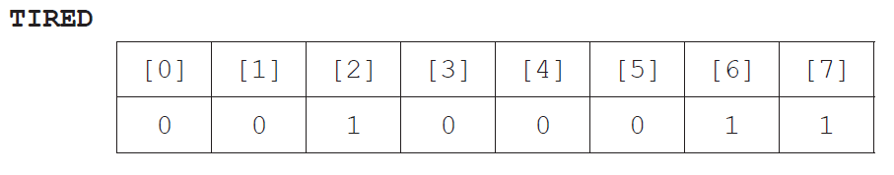

1. Identify a relationship between the value of S and the index of the array TIRED. [1]
2. Construct an algorithm, *TEST*, in pseudocode, to output the conditions *W*, *H* and *S* from

the array *TIRED* for a student who is tired. [4]

A collection, *STUDENT*, is used to hold the name and the array *TIRED* for each student.

1. Outline the way in which your algorithm could be used to output the names of all those

students who are tired due to *Work* **and** *Hunger*. [3]

1. An international organization has offices located across several countries. For some of

its activities, for example human resource management, it has been decided to adopt a

“Software-as-a-Service” (SaaS) solution in order to keep the running costs low.

1. Describe the features of SaaS. [3]
2. Discuss the limitations of SaaS in relation to security. [6]

Each office makes some data available to external customers through the use of an extranet

and allows employees to work from home through a VPN.

1. Define the term extranet. [2]
2. Distinguish between a VPN and an extranet. [4]
3. The faceplate of a car stereo has six buttons for selecting one of six preferred radio stations.

As part of the internal representation of a microprocessor there is an array with six positions,

carrying the information about the radio frequencies, as follows.

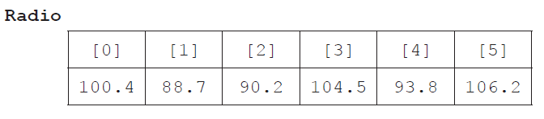

1. State the information at Radio[2]. [1]
2. Outline how a numerical frequency could be stored in a fixed-length string. [2]
3. Construct an algorithm in pseudocode that calculates the range of frequencies

(ie the difference between the highest and lowest frequencies) of any set of six selected

radio stations. [6]

A display in the faceplate shows the name and frequency of the selected radio station. The name  
 is automatically captured when storing a preference.

1. Outline how a collection of objects could be used to store the name and frequency data in

the radio. [2]

1. Construct an algorithm, in pseudocode, to access and display the name and frequency of

a station when a button is pressed. [4]